Yuva Intern

Week 3 Technical Report
Crop Yield Prediction Using Machine Learning
Designing and Evaluating a Machine Learning Model for Crop Yield Prediction
Student | Atharv Vyahalkar
Internship role | Junior Machine Learning Data Analyst: Agriculture & Agribusiness
Academic year | 2026-27
Dataset | Crop Data 24-25 (district-level crop statistics, 2024-25)
Report | Week 3
Submission date | November 2026

Contents
Abstract 4
1. Introduction 4
1.1 Background 4
1.2 Importance of crop yield estimation 4
1.3 Role of machine learning in agriculture 4
1.4 Project motivation 5
2. Problem Statement 5
3. Objectives and Scope 5
3.1 Primary objective 5
3.2 Specific technical objectives 5
3.3 Scope 5
3.4 Limitation to 2024-25 data 5
4. Dataset Description 6
4.1 Dataset origin and accessibility 6
4.2 Dataset attributes 6
4.3 Target variable, units and standardization 6
4.4 Dataset limitations 7
5. Dataset Verification 7
5.1 Checks on the Week 2 matrix 7
5.2 Dataset used in the experiments 7
6. Data Preparation and Feature Selection 7
6.1 Reuse of the Week 2 matrix 7
6.2 Predictors and target 8
6.3 Exclusion of Production to prevent leakage 8
6.4 Predictor selection, leakage exclusion, encoding and feature-selection algorithms 8
6.5 Missing and infinite values 8
6.6 The high-dimensional feature space 8
6.7 Standardization before the split 9
7. Machine Learning Methodology 9
7.1 Workflow 10
7.2 Reproducibility 10
8. Train-Test Split 11
9. Model Development 11
9.1 Dummy Regressor (E1) 11
9.2 Linear Regression (E2) 11
9.3 Decision Tree Regressor (E3) 12
9.4 Random Forest Regressor (E4) 12
9.5 Tuned Random Forest Regressor (E5 and E6) 12
9.6 Experiment log 13
10. Hyperparameter Tuning 13
10.1 Purpose and method 13
10.2 Search space 13
10.3 Cross-validation and the 18 fits 13
10.4 Search results 14
10.5 What the search shows 14
10.6 Best hyperparameters 15
10.7 Cross-validation RMSE versus test RMSE 15
11. Model Evaluation Metrics 15
11.1 Mean Absolute Error 15
11.2 Mean Squared Error 15
11.3 Root Mean Squared Error 16
11.4 Coefficient of determination 16
11.5 Metrics in original units and the inverse transformation 16
11.6 A worked example 16
12. Model Comparison 17
12.1 Comparison table 17
12.2 Why the baseline performs poorly 18
12.3 Each model compared with the baseline 18
12.4 Tuned compared with the other models 18
13. Final Model Selection 19
13.1 Selection 19
13.2 Training versus testing performance 19
14. Feature Importance Analysis 20
15. Actual vs Predicted Analysis 21
15.1 Standardized units 21
15.2 Original units 22
16. Residual Analysis 23
16.1 Residual distribution 23
16.2 Residuals versus predicted yield 24
16.3 Error by crop and season 24
16.4 Extreme errors and zero-yield records 25
17. Results and Discussion 26
17.1 Which model performed best 26
17.2 Why the first Random Forest was weaker than the Decision Tree 26
17.3 How tuning changed the outcome 26
17.4 Predictive importance of variables 26
17.5 What the residuals indicate 26
17.6 Evidence of overfitting 26
17.7 Meaning for the 2024-25 dataset 27
18. Limitations 27
19. Conclusion 27
20. Future Scope 28
References 29
Appendix A. Zero-Yield Records 31
Appendix B. Selected Code 31

Abstract
This report documents Week 3 of the Yuva Intern programme: the design and evaluation of machine learning regression models that estimate crop yield from the 2024-25 district-level agricultural dataset. The experiments use the complete Week 2 ML-ready matrix (9,795 records, 775 columns, no missing, infinite or duplicate values) and were run in a Google Colab notebook [4]. The target is the standardized Yield-2024-25, and the 773 predictors are the one-hot encoded State, District, Crop and Season columns (772) and the standardized Area. Production-2024-25 is excluded because Yield is computed from Production and Area.
Five models were evaluated on an 80:20 random split (7,836 training and 1,959 test records, random_state = 42). The tuned Random Forest, selected by RandomizedSearchCV (6 configurations, 3-fold cross-validation, 18 fits; best cross-validation RMSE 0.5143), performed best, with a test MAE of 0.2632, RMSE of 0.4592 and R² of 0.7843 in standardized yield units. Its RMSE is 53.6% below that of the mean-predicting baseline (0.9891) and 23.3% below that of the best untuned model, the Decision Tree (0.5986). Training R² is 0.8307, which indicates moderate overfitting. The most important features are Crop_Maize (0.2232), Crop_Rice (0.1197), Crop_Moong (0.0819) and Area (0.0704); crop features together account for 61.1% of total importance. Two test records with a reported Yield of zero produce 24.6% of the total squared error.
The study has clear limits. The Week 2 columns were standardized on all records before the split, so test records contributed to the scaling parameters; this limitation remains in the analysis. The data are a single season, the split is random, and the results do not show performance on future seasons or unseen districts. R² and the error measures describe how closely the model's estimates match held-out records from the same season.

1. Introduction

1.1 Background
Agricultural statistics in India are compiled at state, district, crop and season level and published as public datasets. Each record reports the area under a crop, the quantity produced and the resulting yield. Such tables are normally used for description: ranking districts, comparing seasons, or monitoring a crop over time. They also contain enough structure to be used for prediction, because yield varies systematically with the crop grown, the region and the season.

1.2 Importance of crop yield estimation
Yield is the quantity most directly tied to farm income and food supply planning. An estimate of the yield a crop is likely to achieve in a district supports procurement planning and input allocation, and helps identify districts whose productivity departs from what their crop mix would suggest. An estimate is only as useful as its error is understood, which is why this report measures the error of each model and examines where it comes from, instead of reporting a single score.

1.3 Role of machine learning in agriculture
Machine learning regression learns the relationship between input features and a numerical target from historical records. For categorical agricultural data, tree-based ensembles are a common choice because they can represent interactions between factors, for example a crop that yields differently in different states, without those interactions being specified in advance [18]. Linear models and constant baselines are useful companions: they show how much of the target is explained by additive effects alone, and how much a model must beat to be worth using.

1.4 Project motivation
Week 1 explored the 2024-25 crop dataset, and Week 2 turned it into a numerical feature matrix with one-hot encoded categories and standardized numerical columns. Week 3 uses that matrix to ask a concrete question: how much of the variation in yield can be explained by crop, location, season and area alone, and which kind of model explains it best?

2. Problem Statement
Given the State, District, Crop and Season of a record and its Area, estimate its Yield-2024-25 with a regression model. Compare a baseline and four regression models using MAE, MSE, RMSE and R² on held-out data [14]; tune the most promising model without using the test set; and interpret the results, including the model's largest errors and the features it relies on. The work is an academic learning exercise and not a deployed agricultural prediction system.

3. Objectives and Scope

3.1 Primary objective
To develop, train, validate and evaluate machine learning regression models for crop yield estimation, to compare several algorithms on measured performance, to improve the best candidate through hyperparameter tuning, and to interpret the results, following the Week 3 task description [3].

3.2 Specific technical objectives
- Check the Week 2 dataset and separate the target from the predictors, excluding Production-2024-25 to prevent target leakage.
- Split the data 80:20 and evaluate every model on the same held-out test set.
- Establish a baseline (Dummy Regressor) so that every model's gain is measured against a stated reference.
- Train and evaluate Linear Regression, a Decision Tree and a Random Forest.
- Tune the Random Forest with RandomizedSearchCV and 3-fold cross-validation on the training data only.
- Compare training and test performance to assess overfitting, and examine the largest errors.
- Analyse residuals and feature importance to understand what the model relies on.

3.3 Scope
The study covers a single agricultural season (2024-25) and uses a random train-test split. It evaluates five models on one dataset with one fixed random seed. It does not perform temporal validation, group-based validation by district, formal feature selection (RFE, SelectKBest, PCA or similar), deployment, or comparison with external data such as weather or soil.

3.4 Limitation to 2024-25 data
All data belong to the 2024-25 season. The study is therefore a single-season regression study. It estimates yield for held-out records from the same season. It does not demonstrate the ability to predict a future season or a district that was not seen during training.

4. Dataset Description

4.1 Dataset origin and accessibility
The records come from the file Crop Data 24-25.csv [1], which reports district-level crop area, production and yield for 2024-25. A check made on 25 October 2026 for the Week 2 report linked it to a published resource: a file with an identical header, DES-District-Data-For-2024-25.csv, is offered on the "Latest Agriculture Statistics of India" page of Global Agriculture (Krishak Jagat) [2], where it is credited to DA&FW (Department of Agriculture & Farmers Welfare). All 27 rows of the Punjab section that were compared with the supplied file matched exactly on Area, Production and Yield.
The hosting page is a secondary publisher, not the original government portal, and the original portal URL was not located. The primary source URL, the download date of the student's copy and the equivalence of the complete file are therefore not verified and should be confirmed before final submission.

4.2 Dataset attributes
Table 1. Attributes of the source dataset and their role in Week 3
Attribute | Type | Role in the Week 3 experiment
State | Categorical (31 values) | Predictor, one-hot encoded in Week 2
District | Categorical (723 values) | Predictor, one-hot encoded in Week 2
Crop | Categorical (15 individual crops) | Predictor, one-hot encoded in Week 2
Season | Categorical (Kharif, Rabi, Summer) | Predictor, one-hot encoded in Week 2
Area-2024-25 | Numerical | Predictor (log1p and standardized in Week 2)
Production-2024-25 | Numerical | Excluded to prevent target leakage
Yield-2024-25 | Numerical | Target (log1p and standardized in Week 2)

4.3 Target variable, units and standardization
The target column of the Week 2 matrix is Yield-2024-25 after transformation: the original yield was transformed with log1p and then standardized using the mean (7.1540) and standard deviation (0.8081) of log1p(Yield) over all 9,795 records. The notebook uses this column as it is and applies no further transformation to the target or to the features. A standardized value of -8.852 corresponds to a reported Yield of zero, since log1p(0) = 0 standardizes to (0 − 7.154) / 0.808 = −8.852, the minimum of the target.
MAE and RMSE in this report are in standardized yield units, MSE is in squared standardized units, and R² is dimensionless. None of them is a kg/ha error, and standardized predictions are never labelled kg/ha. One standardized unit is 0.8081 units of log1p(Yield). A test MAE of 0.2632 therefore corresponds to about 0.213 on the log1p scale, a typical multiplicative deviation of roughly 24%, and the median absolute residual of 0.1527 to roughly 13%. This translation is approximate and for orientation only. Section 11.5 gives the errors converted back to the original units of the source file.
The units of the source columns are not stated in the CSV. The hosting page states lakh hectares, lakh tonnes and kg per hectare, and Yield ≈ 1,000 × Production / Area within 5% for all 2,980 records with Area of at least 1.0, but these units have not been confirmed at the primary source.

4.4 Dataset limitations
- Single season: the data cover 2024-25 only.
- Area and Production appear to be published with two decimal places, so many small plantings are recorded as 0.00 (4,570 of the 9,795 records have a zero Area) while their Yield is usually positive.
- Many categories have few records: the median district has 15 records and one district has a single record.
- Thirteen records have a reported Yield of exactly zero; their interpretation is uncertain (Section 16.4).

5. Dataset Verification

5.1 Checks on the Week 2 matrix
Before modelling, the notebook loads the Week 2 matrix and checks its shape, data types, missing values and duplicate records. The checks are summarized below; the infinite-value check and the predictor count follow from the same matrix.
Table 2. Checks on the Week 2 matrix
Check | Result
Records | 9,795
Columns | 775 (772 one-hot columns and 3 numerical columns)
Data types | all 775 columns float64
Missing values | 0
Duplicate records | 0
Infinite values | 0
Target column | Yield-2024-25, no missing values
Predictors after excluding the target and Production | 773
One-hot columns | State 31, District 723, Crop 15, Season 3

5.2 Dataset used in the experiments
All 9,795 records are used. No record was removed in the notebook: the missing-value and infinite-value checks found nothing to remove (Section 6.5). The data are split into training and test sets in Chapter 8, and the counts used in the experiments are 7,836 training records and 1,959 test records.

6. Data Preparation and Feature Selection

6.1 Reuse of the Week 2 matrix
Week 3 starts from the dataset prepared in Week 2 [5] and does not repeat its preprocessing narrative: removal of 47 incomplete records, exclusion of aggregate crop categories and the Total season so that records do not overlap, one-hot encoding [15], and log1p transformation and standardization of the numerical columns [16]. Reusing the matrix keeps the encoded columns identical between the two weeks and makes the Week 3 results traceable to the Week 2 preprocessing.

6.2 Predictors and target
The target is Yield-2024-25. The predictors are every other column except Production-2024-25: 772 one-hot columns (State 31, District 723, Crop 15, Season 3) and the standardized Area-2024-25, a total of 773 predictors. The feature matrix has shape (9795, 773) and the target has shape (9795,). No further scaling or transformation is applied to the target or the features; both are used as they appear in the Week 2 matrix. Predictor selection was domain-based: location, crop, season and planted area are the factors an agronomist would expect to influence yield, and they are available for every record. Yield is a per-unit productivity measure, which makes records of different size comparable; predicting Production, by contrast, would largely reproduce the size of the district.

6.3 Exclusion of Production to prevent leakage
Yield is computed from Production and Area:
Yield = k × Production / Area
where k is a constant that depends on the units. In the source file the relation holds within 5% for all 2,980 records with an Area of at least 1.0. A model given Production and Area could recover Yield almost directly, and its apparent performance would reflect this identity instead of a learned relationship between yield and crop, location or season. This is target leakage [17]. Production is dropped together with the target when the predictors are defined (excluded_columns = ["Yield-2024-25", "Production-2024-25"]), so the feature matrix has 773 columns, which is 775 minus these two. Area was kept: it does not determine Yield on its own (the Pearson correlation between standardized Area and Yield is 0.264, against 0.935 between Area and Production), and it is available independently of the harvest. Its use should not be read as a causal effect of area on yield.

6.4 Predictor selection, leakage exclusion, encoding and feature-selection algorithms
Four different things are easily confused, and they are separated here.
- Domain-based predictor selection chose the five candidate predictors on subject-matter grounds. It was implemented by choosing columns.
- Exclusion of a leakage-prone variable removed Production because of its mathematical relationship with the target. It was implemented by dropping that column.
- One-hot encoding converts the four categorical predictors into 772 binary columns (done in Week 2). It changes the representation of the predictors, not which predictors are used.
- Formal feature selection algorithms, such as recursive feature elimination (RFE), SelectKBest or principal component analysis (PCA), were not implemented in the notebook. The feature importance ranking (Chapter 14) is a diagnostic of the fitted model and was not used to drop any feature.

6.5 Missing and infinite values
The notebook checked the matrix (0 missing values, 0 duplicate records), the feature matrix and the training set (0 missing values), and the target (0 missing values). It then created a modelling copy that replaces infinite values with missing values and drops rows with a missing value in any column except Production. The printed result was: initial records 9,795, records removed 0, final modelling records 9,795, remaining missing values 0. The matrix contains no infinite values, so no record was removed.

6.6 The high-dimensional feature space
The models use 773 predictors for 7,836 training records, about 10 records per predictor. The categorical block is very sparse: each record has exactly four active flags among 772 columns (0.52% non-zero). The 723 district columns each describe at most 27 training records (median 11), and one district column has no record in the training set at all (its single record is in the test set), so it can never be used by a model.
High dimensionality matters for tree-based models in three ways. A tree splitting on a district indicator can only fit those few records, which invites overfitting. A Random Forest that considers a random subset of features at each split will, with a small subset, often miss the few strongly informative features: with 773 columns, max_features="sqrt" lets each split see 27 of them, so a given split includes Crop_Maize with probability of only about 3.5%. And importance is diluted across many weak columns: 151 of the 773 features (19.5%) have exactly zero importance in the final model, and the 723 district columns together account for 5.6% of total importance (Chapter 14). No feature selection or dimensionality reduction was applied.

6.7 Standardization before the split
The Area, Production and Yield columns of the matrix were standardized in Week 2 using all 9,795 records, before any train-test split. The scaling parameters (mean and standard deviation) therefore contain information about records that later serve as test data. This is a methodological limitation: the test set is not fully independent of the preprocessing, and the estimate of generalization error can be slightly optimistic [17]. No scikit-learn Pipeline [13] was used, and no preprocessing was fitted on the training partition alone.
Tree-based models are not affected by a monotonic rescaling of the features, and the fit of ordinary least squares is not changed by it either, so the effect on the comparison between the models is expected to be small. It is still a limitation of the procedure, and fitting the encoder and scalers on the training partition inside a Pipeline would be the correct approach for further work (Chapter 20).

7. Machine Learning Methodology
Figure 1 shows the workflow of the experiment. Each stage is described in the chapters that follow.
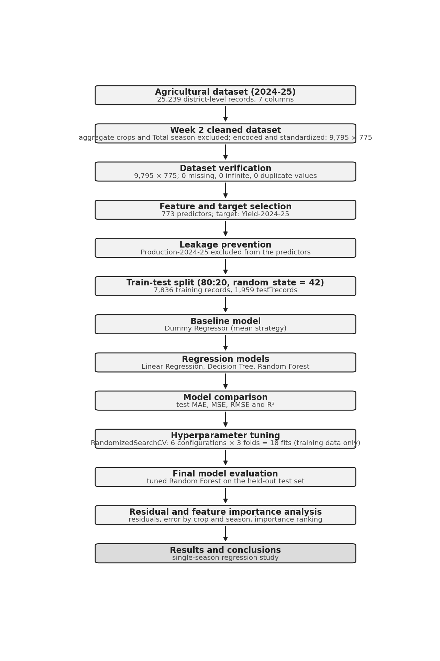
Figure 1. Workflow of the Week 3 notebook, from the 2024-25 dataset to results and conclusions, with the record counts at each stage.

7.1 Workflow
The notebook (1) loads the Week 2 matrix and checks its shape, types, missing values and duplicates; (2) separates the target from the predictors and excludes Production; (3) splits the data 80:20; (4) trains the baseline and three regression models on the training set and scores them on the test set; (5) tunes the Random Forest with RandomizedSearchCV on the training set; (6) evaluates the tuned model once on the test set and on the training set; (7) analyses residuals and feature importance; and (8) exports the comparison, importance and prediction tables.

7.2 Reproducibility
random_state=42 was set for the split, the tree and forest models and the randomized search, so the experiment can be repeated. The versions of Python and scikit-learn used in the Colab session are not recorded in the outputs.

8. Train-Test Split
The data were split with train_test_split(X, y, test_size=0.20, random_state=42) [6]: 7,836 training and 1,959 test records, with no missing values in any part.
A random split was used because the data cover a single season, so there is no time order to respect, and it is the simplest way to hold out a representative 20% of records. Its consequence must be stated clearly: records from the same district appear in both the training and test sets (only 1 of the 1,959 test records belongs to a district with no training record), so the test score measures how well a model estimates yield for combinations of crop, district and season close to ones it has seen. It does not show performance on future years or on unseen districts.
The test set is also small in absolute terms for rare events: it contains 2 of the 13 zero-yield records in the data (the other 11 are in the training set). A different seed would place them differently and could change RMSE and R² noticeably (Section 16.4); the single split gives no estimate of that variation.

9. Model Development
The models were trained on the same 7,836 training records and scored on the same 1,959 test records. Metrics are in standardized yield units; "reduction" figures compare errors with those of the Dummy Regressor unless another comparison is named.

9.1 Dummy Regressor (E1)
Purpose and principle. The baseline predicts the mean of the training targets for every record [7]. It sets the minimum standard: any useful model must beat its error.
ŷᵢ = ȳ_train
Configuration. DummyRegressor(strategy="mean").
Results. MAE 0.7902, MSE 0.9782, RMSE 0.9891, R² -0.0010.
Comparison with the baseline. It is the baseline. Its RMSE equals the standard deviation of the test target (0.9886).
Interpretation. It explains none of the variation in test yield. R² is marginally below zero because the training mean differs slightly from the test mean.
Strengths. No parameters, no overfitting, a fair reference.
Weaknesses. Uses no information about the record.

9.2 Linear Regression (E2)
Purpose and principle. Ordinary least squares fits one coefficient per feature so that the squared training error is minimal [8]. It shows how far additive effects of crop, state, district, season and area go.
ŷ = β₀ + β₁x₁ + β₂x₂ + … + β₇₇₃x₇₇₃
Configuration. LinearRegression() with default settings, 773 predictors.
Results. MAE 0.4308, MSE 0.3963, RMSE 0.6296, R² 0.5944.
Comparison with the baseline. RMSE is 36.3% lower and MAE 45.5% lower than the baseline.
Interpretation. About 59% of the variance in test yield is explained by additive effects, so crop, district and season carry a large part of the signal.
Strengths. Fast and interpretable; a strong starting point [21].
Weaknesses. Cannot represent interactions between factors unless they are encoded as features.

9.3 Decision Tree Regressor (E3)
Purpose and principle. A regression tree repeatedly splits the data on a feature and threshold, choosing the split that minimizes the squared error of the two groups; each leaf predicts the mean target of its training records [19][9]. It tests whether interactions and non-linear effects improve on the linear model.
minimize Σ(yᵢ − ȳ_left)² + Σ(yᵢ − ȳ_right)²
Configuration. DecisionTreeRegressor(max_depth=10, min_samples_split=5, min_samples_leaf=2, random_state=42).
Results. MAE 0.3870, MSE 0.3584, RMSE 0.5986, R² 0.6333.
Comparison with the baseline. RMSE is 39.5% lower and MAE 51.0% lower than the baseline; RMSE is 4.9% lower than Linear Regression's.
Interpretation. The tree improves on the linear model on every metric, so interactions carry additional signal. It was the best untuned model.
Strengths. Captures interactions without scaling.
Weaknesses. A single tree has high variance, and its splits can rest on small groups of records.

9.4 Random Forest Regressor (E4)
Purpose and principle. A Random Forest averages the predictions of many trees, each fitted on a bootstrap sample and considering only a random subset of features at each split [18][10]. It was expected to improve on a single tree.
ŷ = (1 / B) Σ T_b(x), b = 1 … B
Configuration. RandomForestRegressor(n_estimators=100, max_depth=15, min_samples_split=5, min_samples_leaf=2, max_features="sqrt", random_state=42, n_jobs=2).
Results. MAE 0.5442, MSE 0.5405, RMSE 0.7352, R² 0.4469.
Comparison with the baseline. RMSE is 25.7% lower and MAE 31.1% lower than the baseline, but it is worse than both the Decision Tree and Linear Regression.
Interpretation. Contrary to the usual expectation, the forest underperforms the single tree (RMSE 0.7352 against 0.5986). The most likely cause is max_features="sqrt", which lets each split see only 27 of the 773 features, so most splits never see the few informative ones (Section 10.5).
Strengths. Reduces variance and provides feature importances.
Weaknesses. Sensitive to max_features in a sparse, high-dimensional space.

9.5 Tuned Random Forest Regressor (E5 and E6)
The tuned model is the same algorithm with hyperparameters selected by cross-validation on the training data (Chapter 10). Its test results are MAE 0.2632, MSE 0.2108, RMSE 0.4592 and R² 0.7843, which are 66.7% (MAE) and 53.6% (RMSE) below the baseline. Strengths: the best performance in the study, with interactions captured and variance averaged out. Weaknesses: moderate overfitting (Chapter 13) and large errors on very low or very high yields (Chapter 16).

9.6 Experiment log
Table 3. Experiment log
ID | Model | Key configuration | MAE | RMSE | R²
E1 | Dummy Regressor | strategy = mean | 0.7902 | 0.9891 | -0.0010
E2 | Linear Regression | default | 0.4308 | 0.6296 | 0.5944
E3 | Decision Tree | max_depth 10, split 5, leaf 2 | 0.3870 | 0.5986 | 0.6333
E4 | Random Forest | 100 trees, depth 15, split 5, leaf 2, sqrt | 0.5442 | 0.7352 | 0.4469
E5 | RandomizedSearchCV | 6 configurations × 3 folds = 18 fits | - | CV 0.5143 | -
E6 | Tuned Random Forest | 50 trees, depth None, split 5, leaf 2, features 0.5 | 0.2632 | 0.4592 | 0.7843
E7 | Train vs test | tuned model, training set | 0.2165 | 0.4126 | 0.8307
E8 | Residuals and importance | tuned model, test set | - | - | -

10. Hyperparameter Tuning

10.1 Purpose and method
Hyperparameters are settings chosen before training that control how a model learns, for example how deep trees may grow. Tuning searches for settings that generalize better. RandomizedSearchCV draws a fixed number of combinations at random from a search space, scores each by cross-validation and keeps the best [11]. Random search was used because the full grid is large and, for a fixed budget, random sampling explores the space more efficiently than a coarse grid [20].

10.2 Search space
Table 4. Hyperparameter search space
Parameter | Values searched | Role
n_estimators | 50, 100, 150 | Number of trees; more trees reduce variance
max_depth | 10, 15, 20, None | Maximum tree depth; None grows trees until leaves are pure or small
min_samples_split | 2, 5, 10 | Minimum records needed to split a node
min_samples_leaf | 1, 2, 4 | Minimum records in a leaf; larger values smooth predictions
max_features | "sqrt", 0.5 | Features considered at each split (27 or 386 of 773)

The space contains 3 × 4 × 3 × 3 × 2 = 216 combinations, of which 6 were sampled (6 / 216 = 2.8%).

10.3 Cross-validation and the 18 fits
With cv=3, the 7,836 training records were divided into three folds of 2,612 records. For each configuration a forest was fitted on two folds (5,224 records) and scored on the third, three times, and the three RMSE values were averaged. Six configurations multiplied by three folds give the 18 fits printed by the notebook ("Fitting 3 folds for each of 6 candidates, totalling 18 fits"). Cross-validation was used because choosing a configuration by its test score would let test data influence the model, and a single validation split would give a noisy comparison [12]. After the search, the best configuration was refitted on all 7,836 training records. The test set played no part in the search.

10.4 Search results
The notebook prints the best parameters and the best score. The table lists the cross-validation RMSE of all six sampled configurations, taken from the cv_results_ of the same search.
Table 5. Cross-validation results of the six sampled configurations
Config | n_estimators | max_depth | split | leaf | max_features | CV RMSE | Std (folds) | Rank
C1 | 50 | None | 5 | 2 | 0.5 | 0.5143 | 0.0831 | 1
C2 | 50 | None | 10 | 4 | 0.5 | 0.5203 | 0.0810 | 2
C3 | 50 | 20 | 5 | 1 | 0.5 | 0.5446 | 0.0768 | 3
C4 | 50 | None | 10 | 2 | sqrt | 0.6444 | 0.0764 | 4
C5 | 50 | 10 | 10 | 2 | sqrt | 0.8180 | 0.0605 | 6
C6 | 50 | 20 | 5 | 1 | sqrt | 0.6965 | 0.0650 | 5

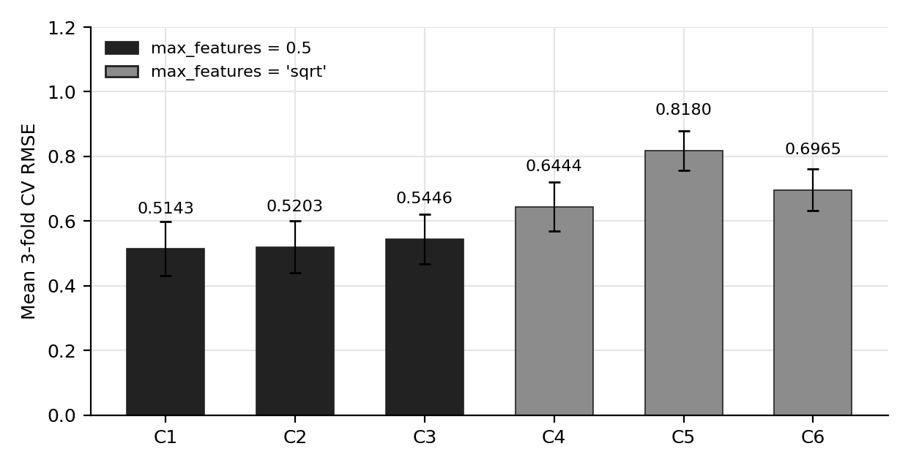
Figure 2. Mean 3-fold cross-validation RMSE of the six sampled configurations, with the standard deviation across folds. The three configurations with max_features = 0.5 (dark bars) have lower mean RMSE than the three with max_features = sqrt (grey bars).

10.5 What the search shows
- max_features separates the two groups. The three max_features=0.5 configurations have a mean CV RMSE of 0.5143 to 0.5446 and the three "sqrt" configurations 0.6444 to 0.8180. Comparing C1 and C4, which differ mainly in max_features (the split setting also differs, 5 against 10), CV RMSE rises from 0.5143 to 0.6444, an increase of 25.3%. This supports the explanation of why the first Random Forest was weak: each of its splits saw 27 of 773 features.
- The fold-to-fold spread is large. The standard deviation across folds is 0.06 to 0.08, because zero-yield and extreme records fall unevenly across folds. The differences among the three best configurations (0.5143, 0.5203, 0.5446) are smaller than this spread and should not be treated as meaningful. The gap between the two max_features groups (about 0.10 or more) is only about one fold standard deviation, so the evidence is suggestive and not conclusive.
- Depth matters for the sqrt configurations. Among them, CV RMSE improves from 0.8180 at depth 10 to 0.6965 at depth 20 and 0.6444 with no limit. The untuned forest had a depth limit of 15.
- All six sampled configurations used 50 trees. The random draw happened not to include 100 or 150 trees. The selected value of 50 shows that 50 trees are sufficient, not that 50 is better than 100 or 150, which were not tested.

10.6 Best hyperparameters
Table 6. Best hyperparameters and comparison with the first Random Forest
Parameter | First Random Forest | Tuned Random Forest
n_estimators | 100 | 50
max_depth | 15 | None
min_samples_split | 5 | 5
min_samples_leaf | 2 | 2
max_features | sqrt | 0.5
Test RMSE | 0.7352 | 0.4592
Test R² | 0.4469 | 0.7843

10.7 Cross-validation RMSE versus test RMSE
The best cross-validation RMSE is 0.5143 and the final test RMSE is 0.4592. They are different quantities computed on different records, and a gap in either direction is not surprising. Each cross-validation model is trained on two thirds of the training data (5,224 records), whereas the final model is refitted on all 7,836, which tends to lower the test error. The folds are drawn from the training data, while the test set is a separate sample, and the two differ in how many extreme records they contain: 11 of the 13 zero-yield records are in the training set (0.14% of its records) and 2 in the test set (0.10%), so some folds contain several of them. Because both scores depend on the sample as well as on the model, the cross-validation score is used to select a configuration, and the test score, which was not used for selection, is reported as the performance estimate.

11. Model Evaluation Metrics
All metrics are computed on the 1,959 test records [14]. Let yᵢ be the actual value, ŷᵢ the predicted value, ȳ the mean of the actual values and n the number of records. R² and the error measures describe how closely the model's estimates match held-out records; R² is not a percentage of correct predictions and is not called accuracy in this report.

11.1 Mean Absolute Error
MAE = (1/n) Σ |yᵢ − ŷᵢ|
MAE is the average size of the error in the units of the target: how far, on average, an estimated yield is from the reported yield. It grows in proportion to each error and is therefore less affected by a few very large errors than the squared metrics. The tuned model's MAE of 0.2632 means that its estimates are on average 0.2632 standardized units from the reported value; the median absolute error is lower, 0.1527, because most estimates are close and a few are far off.

11.2 Mean Squared Error
MSE = (1/n) Σ (yᵢ − ŷᵢ)²
MSE squares the errors, so large errors weigh much more. It is in squared standardized units; for the tuned model it is 0.2108. It is the quantity that the regression models minimize in training, and the baseline's MSE (0.9782) is the variance left unexplained when no feature is used.

11.3 Root Mean Squared Error
RMSE = √MSE
RMSE returns to the units of the target; for the tuned model it is 0.4592 against an MAE of 0.2632. A ratio of RMSE to MAE well above 1 (here 1.74) indicates that a few large errors weigh heavily in the squared metric (Section 16.4). For yield estimation, RMSE is the measure that penalizes districts whose yield is badly missed.

11.4 Coefficient of determination
R² = 1 − Σ (yᵢ − ŷᵢ)² / Σ (yᵢ − ȳ)²
R² compares the model's squared error with that of always predicting the test mean. A value of 1 is a perfect fit, 0 is no better than predicting the mean, and negative values are worse. The tuned model's R² of 0.7843 means that it explains about 78% of the variation in the standardized test yield. R² is dimensionless and is unchanged by an affine rescaling of the target.

11.5 Metrics in original units and the inverse transformation
Standardized metrics can be translated back to the units of the source file by inverting the Week 2 transformation, ŷ_original = expm1(ŷ_standardized × 0.8081 + 7.1540). This conversion is calculated from the test predictions and is not printed by the notebook. Two cautions apply: the units of the source file are not confirmed at the primary source, and R² in original units differs from R² in standardized units because the transformation is non-linear.
Table 7. Tuned Random Forest test errors in standardized and original units (calculated)
Metric | Standardized units | Original units of the source file
MAE | 0.2632 | 308.0
RMSE | 0.4592 | 634.9
R² | 0.7843 | 0.7943
Median absolute error | 0.1527 | 148.8
90th percentile of absolute error | 0.6229 | 719.8

For scale, the test records have a mean yield of 1,685.6 and a standard deviation of 1,399.8 in the original units, so the MAE of 308.0 is about 18% of the mean. The back-transformed prediction estimates a median-like value on the log scale; no smearing correction was applied, so the conversion is approximate for large yields (Chapter 18).

11.6 A worked example
Table 8. Errors for the first five test records (standardized units, from the prediction CSV)
Record | Actual | Predicted | Absolute error | Squared error
0 | -0.4338 | -0.9058 | 0.4721 | 0.2228
1 | 1.2211 | 1.2478 | 0.0267 | 0.0007
2 | -1.4050 | -1.2513 | 0.1537 | 0.0236
3 | 0.3431 | 0.2147 | 0.1284 | 0.0165
4 | 0.7609 | 0.7425 | 0.0184 | 0.0003

Four of these five records are estimated to within 0.16 of the reported value, and the first is off by 0.4721. By contrast, the worst test record is Urad in Bhopal in Summer, with a reported standardized value of -8.852 (a Yield of zero) and an estimate of -1.570, an absolute error of 7.282 and a squared error of 53.0. That one record contributes 53.0 / (1,959 × 0.2108) = 12.8% of the total squared error on its own, which is why RMSE and R² are harsher judgments than MAE.

12. Model Comparison

12.1 Comparison table
The table lists the test-set results of the five models. All five were evaluated on the same test records, and the values are in standardized yield units.
Table 9. Test-set comparison of the five models (standardized yield units)
Model | MAE | MSE | RMSE | R²
Dummy Regressor | 0.7902 | 0.9782 | 0.9891 | -0.0010
Linear Regression | 0.4308 | 0.3963 | 0.6296 | 0.5944
Decision Tree | 0.3870 | 0.3584 | 0.5986 | 0.6333
Random Forest | 0.5442 | 0.5405 | 0.7352 | 0.4469
Tuned Random Forest | 0.2632 | 0.2108 | 0.4592 | 0.7843

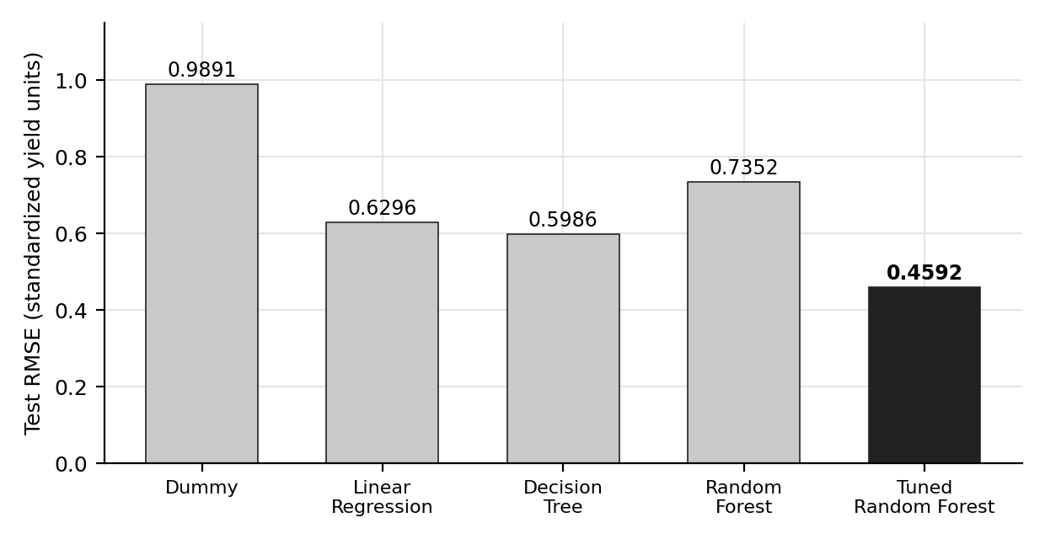
Figure 3. Test RMSE of the five models. The tuned Random Forest has the lowest RMSE (0.4592); the untuned Random Forest (0.7352) is worse than both the Decision Tree (0.5986) and Linear Regression (0.6296).
Pattern and evidence. RMSE falls from 0.9891 for the baseline to 0.4592 for the tuned forest. The untuned Random Forest breaks the sequence: its RMSE is 22.8% above the Decision Tree's. Interpretation. The ordering shows that yield can be estimated much better than by a constant, that interactions help, and that the configuration of the forest matters. Limitation. One split and one seed give no measure of the uncertainty of these values.
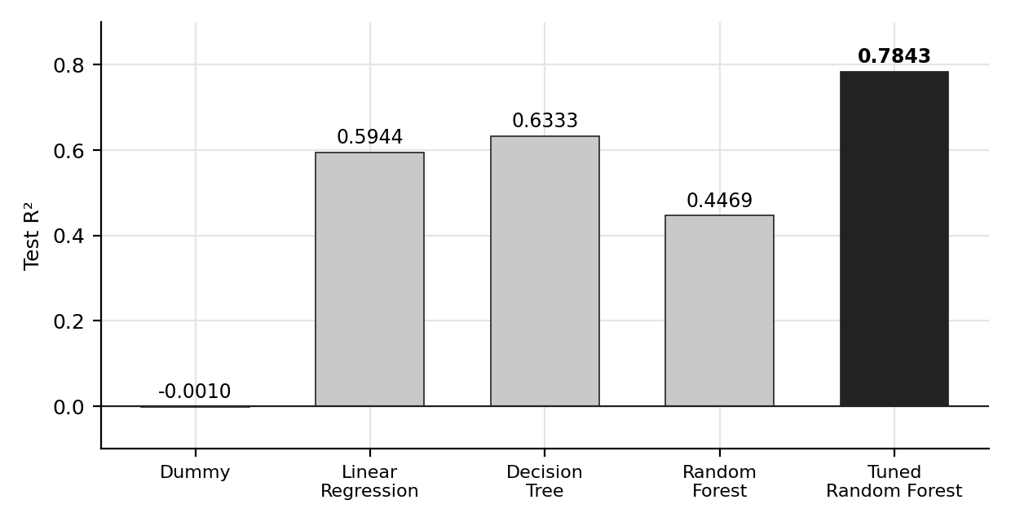
Figure 4. Test R² of the five models. The tuned Random Forest explains 78.4% of the variance in the standardized test yield, compared with 63.3% for the Decision Tree and 44.7% for the untuned Random Forest.
The baseline's R² of -0.0010 is zero within rounding; the Decision Tree and the tuned forest reach 0.6333 and 0.7843, and the untuned forest (0.4469) lies below Linear Regression (0.5944).

12.2 Why the baseline performs poorly
The Dummy Regressor predicts the same value for every record, so its error is the spread of the target itself: its RMSE (0.9891) is essentially the standard deviation of the test target (0.9886) and its R² is about zero. It performs poorly by design; its value is the reference it provides. Every other model has a lower RMSE, which shows that crop, location, season and area carry real information about yield.

12.3 Each model compared with the baseline
Table 10. Reduction in test error relative to the Dummy Regressor
Model | MAE reduction | RMSE reduction | R² gain
Linear Regression | 45.5% | 36.3% | +0.5955
Decision Tree | 51.0% | 39.5% | +0.6343
Random Forest | 31.1% | 25.7% | +0.4480
Tuned Random Forest | 66.7% | 53.6% | +0.7853

Each percentage is the model's error relative to the baseline's error, so the comparison baseline is the Dummy Regressor in every row.

12.4 Tuned compared with the other models
Table 11. Reduction in error of the tuned Random Forest compared with each other model
Compared with (baseline) | MAE reduction | MSE reduction | RMSE reduction | R² gain
Dummy Regressor | 66.7% | 78.4% | 53.6% | +0.7853
Linear Regression | 38.9% | 46.8% | 27.1% | +0.1898
Decision Tree | 32.0% | 41.2% | 23.3% | +0.1510
Random Forest (untuned) | 51.6% | 61.0% | 37.5% | +0.3373

Here the comparison baseline changes by row. Against the untuned forest the tuned forest cuts MAE by about half (0.5442 to 0.2632) and RMSE by 37.5% (0.7352 to 0.4592), with fewer trees (50 instead of 100). Against the best untuned model, the Decision Tree, RMSE is 23.3% lower.

13. Final Model Selection

13.1 Selection
The model with the lowest test RMSE (idxmin of the RMSE column of the comparison table) is the tuned Random Forest. Its hyperparameters were chosen by cross-validation on the training data only, so the test set did not influence the model, and the test comparison is made on the same records for all five models. The tuned Random Forest is also best on MAE, MSE and R². Its RMSE is 53.6% below the baseline, 27.1% below Linear Regression, 23.3% below the Decision Tree and 37.5% below the untuned forest. A single test split and one random seed cannot establish the margin precisely, and the selection should be read with that limitation in mind.

13.2 Training versus testing performance
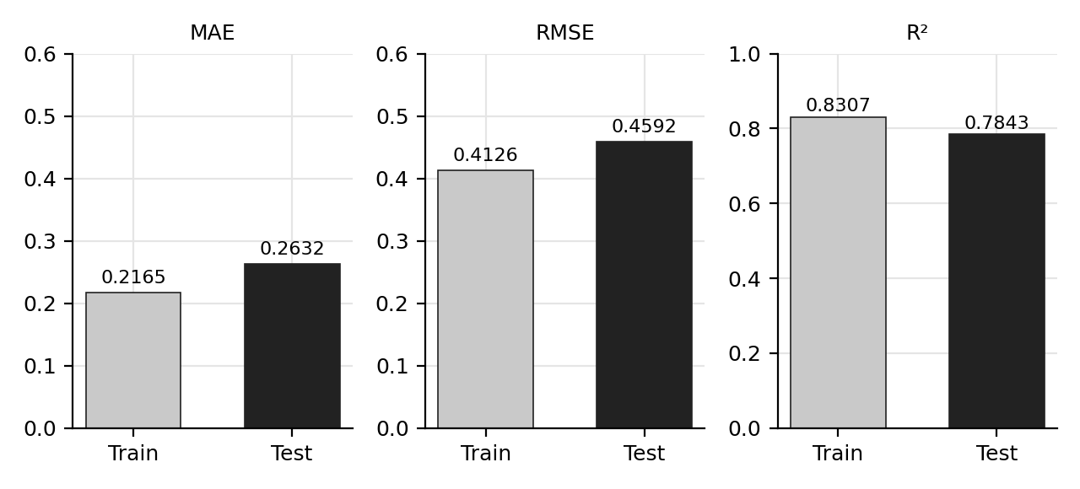
Figure 5. Training and testing MAE, RMSE and R² of the tuned Random Forest. Test error is higher and test R² lower than on the training data, with a moderate gap.
Table 12. Training and test metrics of the tuned Random Forest (standardized units)
Metric | Training | Testing | Difference
MAE | 0.2165 | 0.2632 | +0.0467 (test is 1.22 times training)
RMSE | 0.4126 | 0.4592 | +0.0466 (1.11 times)
R² | 0.8307 | 0.7843 | -0.0464

Pattern and evidence. The model fits the training data better than the test data on every metric, which is evidence of overfitting. The size of the gap is moderate: test RMSE is 11% above training RMSE, and R² falls by 0.046, from 0.8307 to 0.7843. Interpretation. A forest with no depth limit and leaves of at least 2 records can fit its training data closely, so some gap is expected. A test R² of 0.7843 is positive and far above the baseline, so the model estimates held-out records from the same dataset usefully. Limitation. This does not extend to future years or unseen districts: because of the random split, nearly every test record shares its district with training records. The training R² of 0.8307 should not be quoted as expected performance, and the training and test sets are not fully independent of the Week 2 standardization (Section 6.7).

14. Feature Importance Analysis
Random Forest importance is the mean decrease in impurity: each time a feature is used to split a node, the reduction in squared error is credited to it, summed over all trees and normalized to add to 1 (the 773 values add to 1.0000) [10][21]. A high value means the feature was frequently used for splits that reduce error. The values come from best_rf_model.feature_importances_, the tuned model fitted on the training data.
Table 13. Fifteen most important features of the tuned Random Forest
Rank | Feature | Importance | Cumulative
1 | Crop_Maize | 0.2232 | 0.2232
2 | Crop_Rice | 0.1197 | 0.3428
3 | Crop_Moong | 0.0819 | 0.4247
4 | Area-2024-25 | 0.0704 | 0.4950
5 | Crop_Wheat | 0.0611 | 0.5561
6 | Crop_Urad | 0.0464 | 0.6025
7 | State_Chhattisgarh | 0.0262 | 0.6287
8 | Crop_Barley | 0.0249 | 0.6536
9 | State_Maharashtra | 0.0212 | 0.6749
10 | Season_Kharif | 0.0207 | 0.6955
11 | State_Tamil Nadu | 0.0184 | 0.7139
12 | State_Karnataka | 0.0128 | 0.7267
13 | State_Rajasthan | 0.0124 | 0.7391
14 | State_Telangana | 0.0123 | 0.7514
15 | State_Andhra Pradesh | 0.0122 | 0.7636

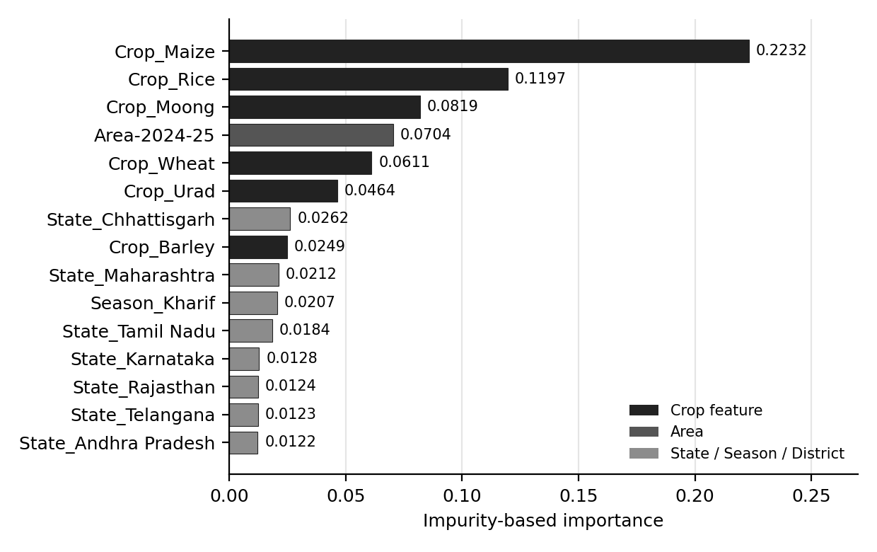
Figure 6. The 15 most important features of the tuned Random Forest. Six of the top fifteen are crop indicators and seven are state indicators; Area ranks fourth and Season_Kharif tenth.
Pattern and evidence. Crop identity dominates: Crop_Maize alone has an importance of 0.2232, and the first six features (five crops and Area) carry 0.6025 of the total. Area ranks fourth at 0.0704. The first state feature, State_Chhattisgarh, is at rank 7, and Season_Kharif is the only season feature in the top fifteen (rank 10). No district feature is in the top fifteen.
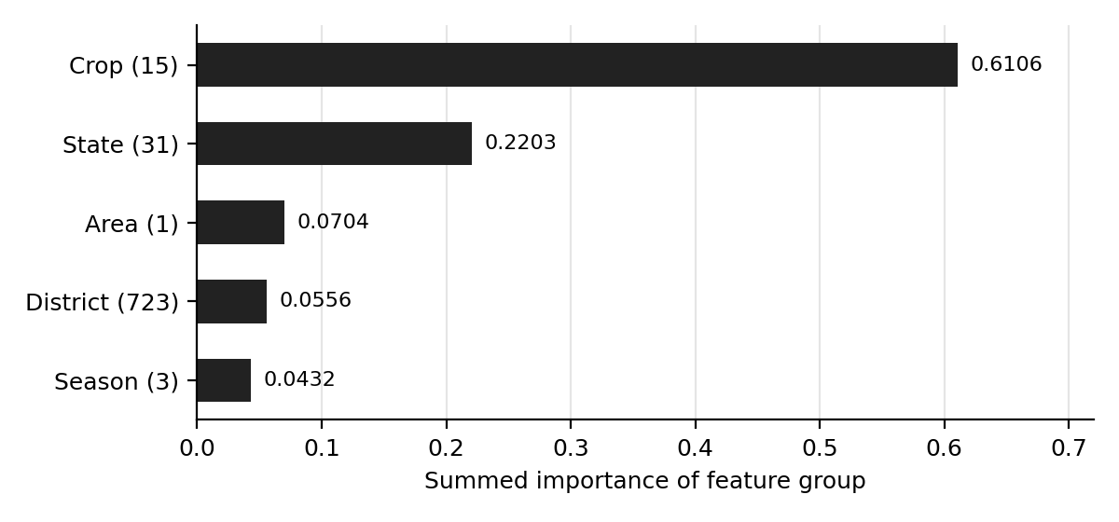
Figure 7. Summed importance by feature group. The 15 crop features carry 61.1% of the total importance, the 31 state features 22.0%, and the 723 district features only 5.6%.
Grouped, the importance is: Crop 0.6106 (15 features), State 0.2203 (31; 30 with non-zero importance), Area 0.0704 (1), District 0.0556 (723; 573 non-zero) and Season 0.0432 (3). The 723 district features hold little importance in total, and 151 of the 773 features have exactly zero importance.
Feature importance does not establish causation. It describes how the fitted model relies on its inputs, not how yield is produced. Crop_Maize ranks first because crops differ in their typical standardized yield, so knowing the crop reduces error; this does not mean that choosing maize raises yield, and no statement in this report assigns a higher yield to a particular crop, state or district as a cause. Impurity-based importance also favours features that offer many useful split points, shares credit among correlated features, is computed on the training data, and gives no direction of effect [22]. Permutation importance on held-out data [23] would be a less biased complement; it was not performed and is listed as future work.

15. Actual vs Predicted Analysis

15.1 Standardized units
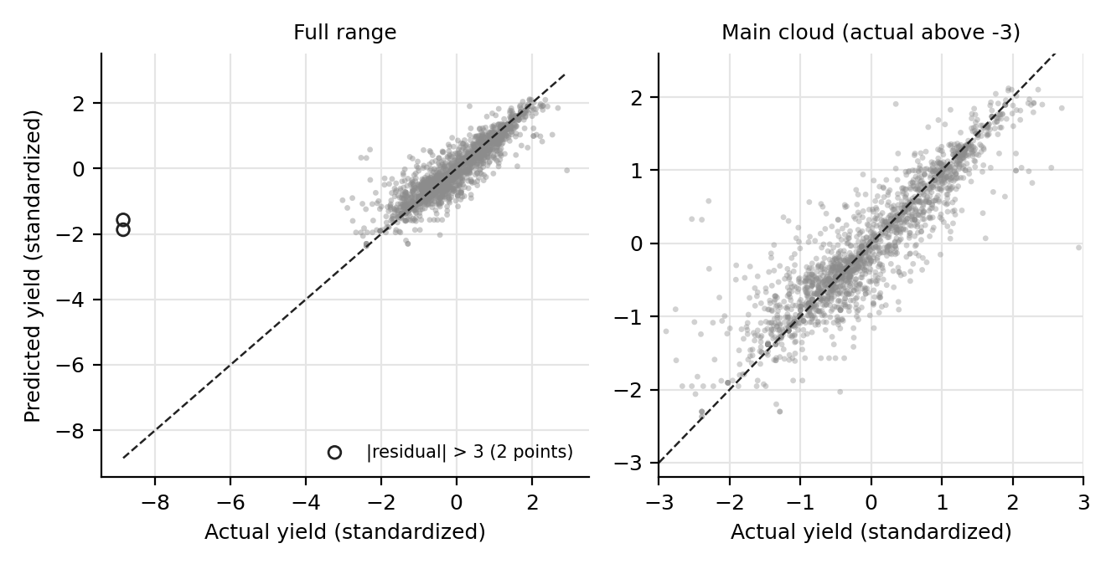
Figure 8. Actual versus predicted standardized yield for the tuned Random Forest on the 1,959 test records. The dashed line is perfect prediction. Left: full range, with the two records whose residual exceeds 3 circled. Right: the main cloud.
Pattern and evidence. Most points lie close to the diagonal from about -2 to 2.9, which fits the R² of 0.7843 and the median absolute error of 0.1527. Within ±1, 96.6% of test estimates fall. In the right-hand panel, the vertical scatter around the diagonal is wider at low actual values. The left panel shows two records with an actual value of -8.852 (a reported Yield of zero) and estimates of -1.87 and -1.57. The model's lowest estimate in the test set is -2.37 and its highest 2.12, so it never estimates values near -8.8.
Interpretation and limitation. The model reproduces the broad structure of yield well, but cannot reproduce the extreme low values, because nothing in the features distinguishes those records (Section 16.4). The standardized scale also exaggerates the importance of low yields: log1p places a yield of zero 8.8 standard deviations below the mean.

15.2 Original units
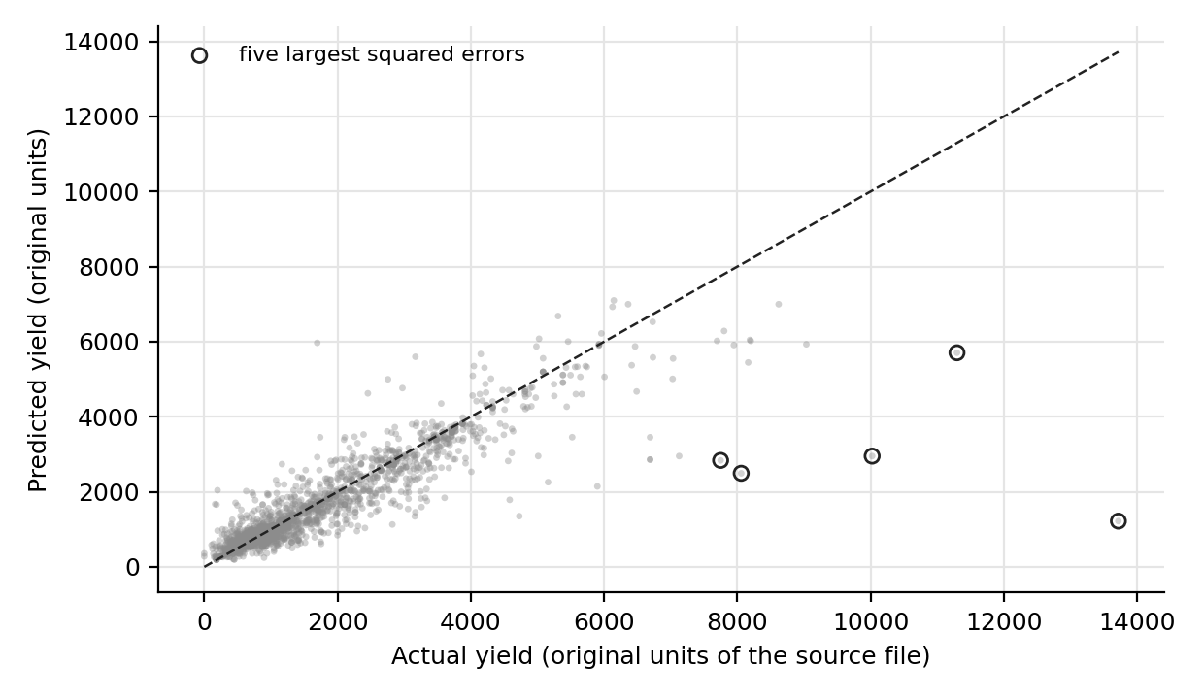
Figure 9. Actual versus predicted yield in the original units of the source file (inverse-transformed), with the five largest squared errors circled. All five have actual yields above 7,000 and are underestimated.
Pattern and evidence. In original units the picture is different. Estimates follow the diagonal below about 4,000 and flatten above it, and the largest errors are all underestimates of high-yield records. The five largest squared errors are Nalgonda Other Pulses Rabi (actual 13,717, estimate 1,219), Rajsamand Other Pulses Rabi (10,022 against 2,952), Malda Maize Rabi (11,295 against 5,705), Guntur Shree Anna Rabi (8,057 against 2,494) and Sikar Other Pulses Rabi (7,748 against 2,837). They account for 37.0% of the total squared error in original units, and the Nalgonda record alone for 19.8%; without them the original-unit RMSE would be 504.4 instead of 634.9. Three of the five have an Area of 0.01 or less in the source (rounded to two decimals).
Interpretation and limitation. Tree ensembles average training targets in a leaf, so they cannot estimate values beyond those typical of similar training records. These very high yields on tiny planted areas are of the kind flagged as unreliable in Week 2: a yield computed from values below reporting precision. The Nalgonda record is also the largest positive residual on the standardized scale (+2.994, just under the threshold of 3). Together, the standardized view (dominated by zero yields) and the original-unit view (dominated by very high yields) show that the model's weak points are at both extremes, and the source records should be checked.

16. Residual Analysis

16.1 Residual distribution
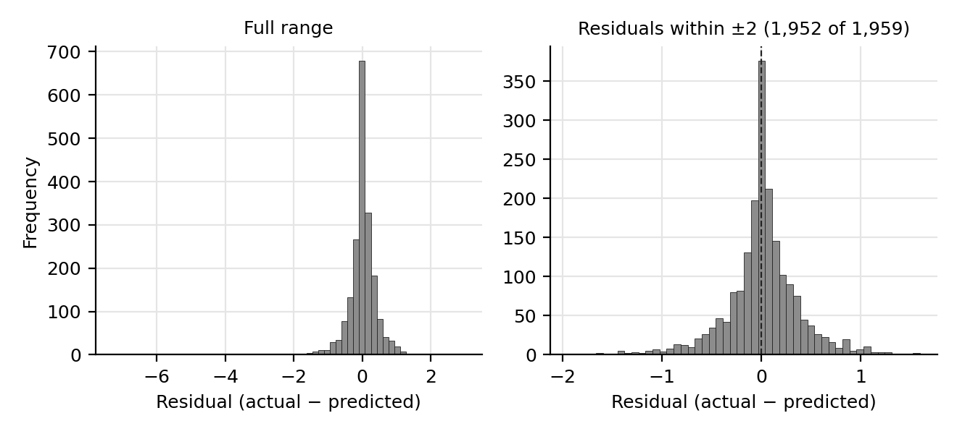
Figure 10. Distribution of test residuals (actual minus predicted, standardized). Left: full range, where the tail is visible only as isolated counts. Right: the 1,952 residuals within ±2, which form a narrow, nearly symmetric peak around zero.
Table 14. Summary of the test residuals (standardized units)
Statistic | Value
Mean | 0.0015
Median | 0.0151
Standard deviation | 0.4592
Median absolute residual | 0.1527
Within ±0.25 | 63.8% of records
Within ±0.5 | 85.3%
Within ±1 | 96.6%
Larger than 2 in magnitude | 7 records (0.36%)
Larger than 3 in magnitude | 2 records, both negative (-6.983 and -7.282)
Skewness | -4.23

Pattern and evidence. The peak is centred at zero (mean 0.0015, median 0.0151), so there is no systematic over- or underestimation on the standardized scale. The skewness of -4.23 comes from the few large negative residuals, in which the model estimated a higher yield than the record reported. Interpretation and limitation. The two records beyond ±3 are 0.10% of the test set but contribute 24.6% of the squared error; without them the RMSE would be 0.3988 and R² 0.8230. These figures show how concentrated the error is. They are not a legitimate performance claim, because the records are part of the data and the model would meet such records in use.

16.2 Residuals versus predicted yield
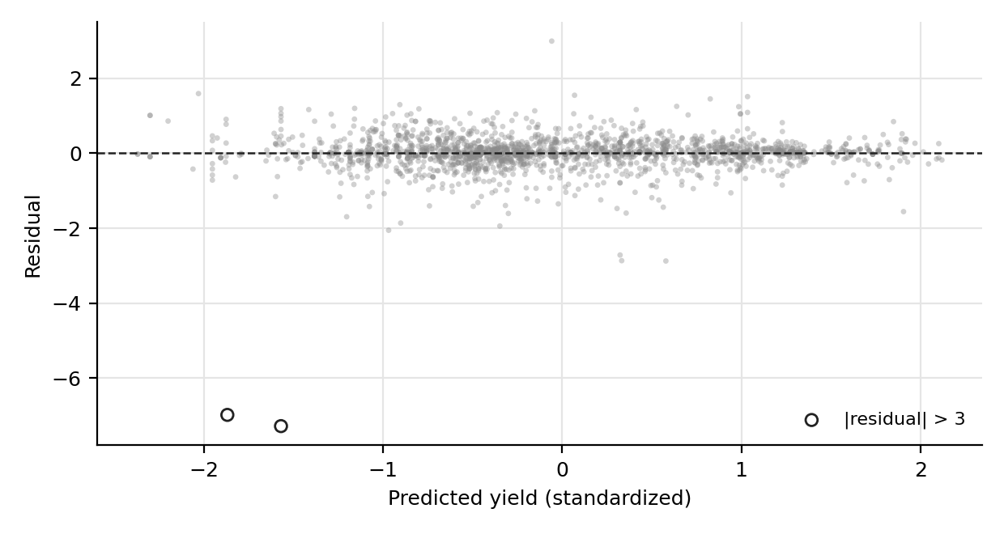
Figure 11. Test residuals against predicted standardized yield. The band around zero has roughly constant width over most of the range and narrows at the highest estimates; the two isolated points far below the line are the records with a reported Yield of zero.
Pattern and evidence. There is no visible curve or trend: the correlation between the estimates and the residuals (excluding the two extreme records) is -0.014. The spread is not constant. Excluding those two records, the residual standard deviation is 0.436 for estimates at or below -1 (240 records), 0.404 between -1 and 0 (864), 0.435 between 0 and 1 (553) and 0.259 above 1 (300). Interpretation and limitation. The model shows no systematic bias at any predicted level but is more precise for records it estimates as high-yielding. The two extreme residuals occur at estimates of -1.87 and -1.57, so the model's own output gave no sign that these records were unusual.

16.3 Error by crop and season
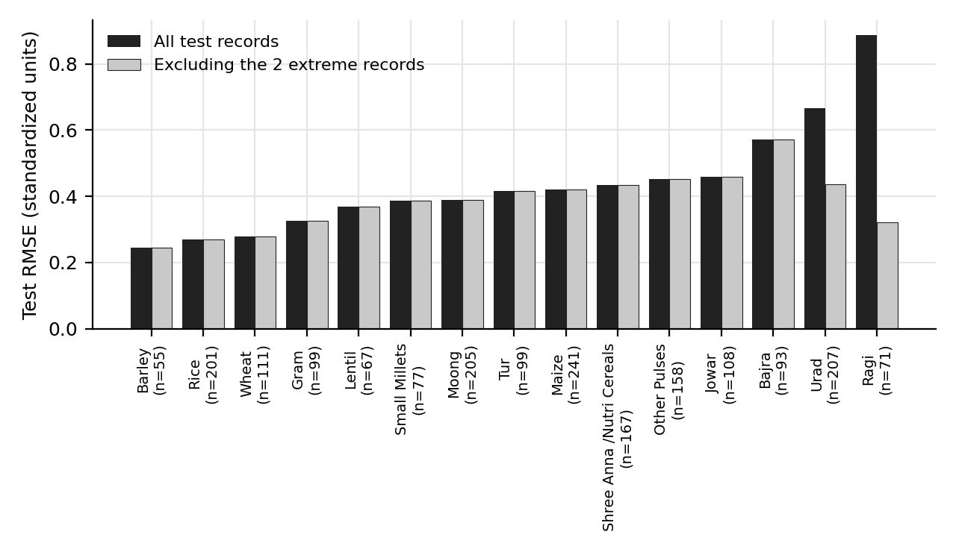
Figure 12. Test RMSE by crop with the number of test records, for all test records and after excluding the two extreme-residual records. Ragi and Urad change markedly; all other crops are unaffected.
Pattern and evidence. The per-crop RMSE ranges from 0.2450 (Barley) and 0.2695 (Rice) to 0.6669 (Urad) and 0.8877 (Ragi). The high values of Urad and Ragi come from the two extreme records (Urad in Bhopal and Ragi in Jamtara, both with a reported Yield of zero): excluding them, Urad falls to 0.4352 and Ragi to 0.3205, and the range across crops becomes 0.2450 to 0.5715 (Bajra). By season, Kharif has an RMSE of 0.4669 (1,042 records), Rabi 0.3890 (673) and Summer 0.5870 (244); excluding the two records, Kharif is 0.4139, Rabi 0.3890 and Summer 0.3573. MAE by season is 0.2754, 0.2446 and 0.2626.
Interpretation and limitation. Crop-level and season-level differences in RMSE are mostly the effect of those two records, so the subgroup figures should not be read as differences in how well the model understands each crop. Several groups have under 100 test records (Barley 55, Lentil 67, Ragi 71, Small Millets 77, Bajra 93), so their RMSE values are themselves uncertain.

16.4 Extreme errors and zero-yield records
Confirmed facts. The 9,795 records contain 13 with a reported Yield of exactly zero (0.13%); 11 are in the training set and 2 in the test set. All 13 have a Production of 0.00; 12 have an Area of 0.00 and one (Gram in Jodhpur, Rabi) has an Area of 0.27. Seven are Urad in Summer in seven Madhya Pradesh districts, two are in Himachal Pradesh, two in Jharkhand (Jamtara), one is Rice in Vijayapura, Karnataka (Summer) and one is the Jodhpur Gram record (Appendix A). A zero yield is unusual among records that look similar: of the 4,198 records with both Area and Production shown as 0.00, 4,186 have a positive Yield and only 12 a Yield of zero. In the seven Madhya Pradesh districts the Kharif Urad record has a positive yield (409 to 714). The two test records have standardized residuals of -6.983 (Ragi, Jamtara, Kharif) and -7.282 (Urad, Bhopal, Summer).
Why these records are so influential. The target is log1p-transformed before standardization, which places a yield of zero 8.8 standard deviations below the mean (-8.852), far outside the range of other records (after the 13 zero-yield records, the next lowest are three near-zero yields at about -7.5, -5.3 and -5.1, and every other record lies above -3.2). Squared errors grow with the square of the residual, so two records with residuals near 7 contribute 24.6% of the total squared error although they are 0.10% of the test set. Their share of the total absolute error is only 2.8% (14.27 of 515.6). This is why they move RMSE and R² far more than MAE: removing them would change RMSE from 0.4592 to 0.3988 and R² from 0.7843 to 0.8230 but MAE only from 0.2632 to 0.2562. In original units the same two records are overestimated by only 281 and 359, small compared with the 12,498 underestimate of the Nalgonda record, so their effect is a property of the standardized log scale.
Why the model cannot estimate them. Nothing in the features isolates these records. A zero Area is shared by 4,570 records, of which only 12 (0.26%) have a zero yield, so Area does not signal a zero yield. Even for Urad in Summer, the most concentrated group, only 7 of 197 records (3.6%) have a zero yield, so the best estimate for that group remains a positive yield: the model gives -1.57 for the Bhopal record. A model that minimizes squared error on the log scale will not estimate values that are almost never seen in similar records.
Why a zero yield cannot be assumed to be a crop failure. The data show only that the published Production is zero. Several explanations are possible and the supplied material cannot separate them: a genuine failure or non-harvest, a crop that was not grown in that season (with a placeholder row), a missing value recorded as zero, or a data-entry artefact. The Jodhpur Gram record is the closest to a real zero, with an Area of 0.27 and no production; the seven Summer Urad records, with an Area of 0.00, are more consistent with a crop barely grown. These are interpretations, not findings. The cause should be established by checking the original source records before any treatment is chosen.
Why they must not be deleted to improve the metrics. The records are part of the published data, and the model will meet records like them. Removing them would raise R² from 0.7843 to 0.8230, but only by hiding a failure that the test set rightly contains, and it would make the reported performance inapplicable to exactly the kind of record whose treatment is uncertain. They are therefore kept in the headline evaluation. If the source confirms that they are not genuine zeros, they could be treated as missing in a future experiment, and the change should be documented.

17. Results and Discussion

17.1 Which model performed best
The tuned Random Forest was best on all four metrics (MAE 0.2632, RMSE 0.4592, R² 0.7843). Its RMSE is 53.6% below the baseline, 27.1% below Linear Regression, 23.3% below the Decision Tree and 37.5% below the untuned forest. Its advantage over the Decision Tree is larger for MAE (32.0%) than for RMSE (23.3%): the ensemble's gain is concentrated in typical records, while the squared metrics are held back by a few extreme ones.

17.2 Why the first Random Forest was weaker than the Decision Tree
The two models used similar leaf and split limits, but they consider features differently. The tree evaluates all 773 features at every split and can use Crop and Area immediately. The first forest examined 27 randomly chosen features per split. Only a handful of the 773 features are strongly informative (the first six carry 0.6025 of the importance), so most splits did not include any of them and were made on weak district columns. The cross-validation results are consistent with this: the three sqrt configurations scored 0.6444 to 0.8180 and the three max_features=0.5 configurations 0.5143 to 0.5446. The evidence is suggestive and not decisive, because the fold-to-fold spread is as large as the gap. The lesson is that default-like Random Forest settings are not neutral in a sparse one-hot feature space.

17.3 How tuning changed the outcome
Tuning changed three settings: max_features from sqrt to 0.5, max_depth from 15 to None and n_estimators from 100 to 50. Test RMSE improved from 0.7352 to 0.4592 and R² from 0.4469 to 0.7843. The search sampled 6 of 216 combinations, so the selected configuration is the best of those six and not necessarily the best available.

17.4 Predictive importance of variables
Crop is the most informative variable group (importance 0.6106 over 15 columns), followed by State (0.2203), Area (0.0704), District (0.0556) and Season (0.0432). For this dataset, knowing which crop a record refers to explains much more of its yield than knowing where it was grown. This is an observation about the fitted model and not a causal statement.

17.5 What the residuals indicate
Residuals are centred on zero, 96.6% lie within ±1, and there is no trend against the predicted value, although the spread is smaller at high estimates. The error is concentrated in a few records: two produce 24.6% of the squared error on the standardized scale, and five produce 37.0% on the original scale. Whether these records are genuine zeros, missing production recorded as zero, or artefacts of low reporting precision cannot be determined from the supplied material, and it is the largest source of uncertainty in the reported RMSE and R².

17.6 Evidence of overfitting
Training R² of 0.8307 against test R² of 0.7843, and training RMSE of 0.4126 against 0.4592, show moderate overfitting. The test R² remains far above the baseline's, and the improvement over every other model shows that the model has learned patterns that carry over to held-out records from the same season.

17.7 Meaning for the 2024-25 dataset
Within this single season, standardized yield can be estimated with a typical error of 0.26 standardized units (about 308 in the units of the source file, which are unverified), and about 78% of its variance can be explained from crop, location, season and area. The study is exploratory, says nothing about other years, and, because the split is random, nearly every test record shares its district with training records.

18. Limitations
Table 15. Limitations and how they could be addressed
Limitation | Detail | Possible remedy
Standardization before the split | Week 2 scaling parameters were computed on all records before the split, so the test set is not fully independent of the preprocessing | Fit encoders and scalers on the training partition only inside a pipeline
Single season | Only 2024-25 data; no trend or year-to-year variation | Add further years
No temporal validation | The study cannot show future-season performance | Train on earlier years, test on a later year
Random split | Nearly all test records share a district with training records (1 of 1,959 does not) | Group-based validation by district or state
One split, one seed | No confidence interval; the test set holds only 2 of the 13 zero-yield records, so metrics depend on the split | Repeated or nested cross-validation
High-dimensional encoding | 773 predictors for 7,836 training records; 151 zero-importance features; one district column unusable | Feature selection, grouping of rare districts, other encodings
Transformed target | Models are fitted on standardized log1p(Yield); original-unit values are a calculated conversion with no smearing correction | Report calibrated original-unit errors; compare with a model on the raw target
Units unverified | Original units are stated by the hosting page but not confirmed at the primary source | Confirm with the source
Extreme and zero-yield records | Zero yields cannot be explained from the supplied data; very high yields on near-zero area are unreliable | Check the original source records; consider robust loss functions
Small search | 6 of 216 configurations tried; all used 50 trees; fold standard deviation about 0.08 | Larger search; export the tuning results from the notebook
Feature importance | Impurity-based, computed on training data, not causal; no permutation importance | Permutation importance on held-out data
Dataset provenance | Primary portal URL, download date and complete-file equivalence unverified | Confirm the source of the file
No external validation | No field data or deployment | Compare estimates with independent records

19. Conclusion
This study built and evaluated machine learning regression models that estimate crop yield from State, District, Crop, Season and Area in the 2024-25 dataset, using the complete 9,795-record Week 2 matrix. Production was excluded from the predictors because Yield is derived from it. Five models were compared on one 80:20 split (7,836 training and 1,959 test records). A search of 6 configurations with 3-fold cross-validation (18 fits) selected a Random Forest with max_features=0.5 and no depth limit.
The tuned Random Forest reached a test MAE of 0.2632, RMSE of 0.4592 and R² of 0.7843 in standardized units, improving on the baseline by 53.6% in RMSE, on the Decision Tree by 23.3%, and on the untuned forest by 0.3373 in R². Comparing the models showed that configuration can matter more than the choice of algorithm: with max_features="sqrt" in 773 sparse features the forest was worse than a single tree. Diagnostics showed that most estimates are close (96.6% within ±1 standardized unit), that crop is the most important feature group, and that a few extreme records, including zero-yield records, account for a large share of the squared error.
The work demonstrates a complete and reproducible regression workflow with a baseline, a leakage-aware predictor set, cross-validated tuning and diagnostics. It does not demonstrate performance on future seasons, on unseen districts or in the field. The Week 2 standardization was fitted before the split, which remains a limitation. The results come from one random split of one season and should be read as a learning exercise.

20. Future Scope
- Multiple agricultural years and temporal validation. Train on earlier seasons and test on a later one, to measure genuine forecasting ability.
- Group-based validation. Hold out whole districts (or states) so that the test measures generalization to unseen locations.
- Improved preprocessing pipelines. Build the encoder and scalers inside a scikit-learn Pipeline and fit them on the training partition only; repeated or nested cross-validation would add confidence intervals.
- Feature selection and dimensionality reduction. Group rare districts, try frequency or target encoding for District, and evaluate RFE or PCA, none of which was performed here.
- Permutation importance. Measure importance on held-out data to complement the impurity-based ranking [23].
- Weather, rainfall, soil and irrigation features. These are likely to explain variation that crop and location cannot.
- Further tuning and models. A wider search, including more trees, gradient boosting, and loss functions less sensitive to extreme records; export the full tuning table from the notebook.
- Verification of extreme records. Check the zero-yield and near-zero-area records against the original source before deciding how to treat them.
- Decision-support applications. If validated on multi-year data and expressed in verified original units, such a model could be considered for district-level planning tools. That is a future possibility and not a result of this study.

References
- Crop Data 24-25.csv. District-level crop area, production and yield, 2024-25. File supplied for the Yuva Intern project.
- Global Agriculture (Krishak Jagat). Latest Agriculture Statistics of India: All India: District and Crop wise Area, Production & Yield of All Crops (2024-25), file DES-District-Data-For-2024-25.csv; source credited to DA&FW. Secondary publisher. https://www.global-agriculture.com/latest-agriculture-statistics-of-india/ (accessed 25 October 2026).
- Yuva Intern. Week 3 task description: designing and evaluating a machine learning model for crop yield prediction. Supplied with the project materials.
- Week3.ipynb. Google Colab notebook by the author containing the code and outputs of the experiments; exports Week3_Model_Comparison_Results.csv, Week3_Feature_Importance.csv and Week3_Prediction_Results.csv.
- Yuva Intern Week 2 technical report: Data preprocessing, cleaning and transformation for agricultural data. Report by the author.
- Pedregosa, F., et al. (2011). Scikit-learn: Machine learning in Python. Journal of Machine Learning Research, 12, 2825-2830.
- scikit-learn developers. sklearn.dummy.DummyRegressor. https://scikit-learn.org/stable/modules/generated/sklearn.dummy.DummyRegressor.html
- scikit-learn developers. sklearn.linear_model.LinearRegression. https://scikit-learn.org/stable/modules/generated/sklearn.linear_model.LinearRegression.html
- scikit-learn developers. sklearn.tree.DecisionTreeRegressor. https://scikit-learn.org/stable/modules/generated/sklearn.tree.DecisionTreeRegressor.html
- scikit-learn developers. sklearn.ensemble.RandomForestRegressor. https://scikit-learn.org/stable/modules/generated/sklearn.ensemble.RandomForestRegressor.html
- scikit-learn developers. sklearn.model_selection.RandomizedSearchCV. https://scikit-learn.org/stable/modules/generated/sklearn.model_selection.RandomizedSearchCV.html
- scikit-learn developers. Cross-validation: evaluating estimator performance. https://scikit-learn.org/stable/modules/cross_validation.html
- scikit-learn developers. Pipelines and composite estimators. https://scikit-learn.org/stable/modules/compose.html
- scikit-learn developers. Metrics and scoring: quantifying the quality of predictions. https://scikit-learn.org/stable/modules/model_evaluation.html
- scikit-learn developers. sklearn.preprocessing.OneHotEncoder. https://scikit-learn.org/stable/modules/generated/sklearn.preprocessing.OneHotEncoder.html
- scikit-learn developers. sklearn.preprocessing.StandardScaler. https://scikit-learn.org/stable/modules/generated/sklearn.preprocessing.StandardScaler.html
- scikit-learn developers. Common pitfalls and recommended practices (data leakage). https://scikit-learn.org/stable/common_pitfalls.html
- Breiman, L. (2001). Random forests. Machine Learning, 45(1), 5-32.
- Breiman, L., Friedman, J. H., Olshen, R. A., and Stone, C. J. (1984). Classification and Regression Trees. Wadsworth.
- Bergstra, J., and Bengio, Y. (2012). Random search for hyper-parameter optimization. Journal of Machine Learning Research, 13, 281-305.
- Hastie, T., Tibshirani, R., and Friedman, J. (2009). The Elements of Statistical Learning (2nd ed.). Springer.
- Strobl, C., Boulesteix, A.-L., Zeileis, A., and Hothorn, T. (2007). Bias in random forest variable importance measures: Illustrations, sources and a solution. BMC Bioinformatics, 8, 25.
- scikit-learn developers. Permutation feature importance. https://scikit-learn.org/stable/modules/permutation_importance.html

Appendix A. Zero-Yield Records
Table 16. Records with Yield = 0 in the 9,795-record dataset (Production is 0.00 in all)
State | District | Crop | Season | Area | Set
Himachal Pradesh | Lahaul And Spiti | Wheat | Rabi | 0.00 | train
Himachal Pradesh | Lahaul And Spiti | Barley | Rabi | 0.00 | train
Jharkhand | Jamtara | Ragi | Kharif | 0.00 | test
Jharkhand | Jamtara | Shree Anna /Nutri Cereals | Kharif | 0.00 | train
Karnataka | Vijayapura | Rice | Summer | 0.00 | train
Madhya Pradesh | Bhopal | Urad | Summer | 0.00 | test
Madhya Pradesh | Dhar | Urad | Summer | 0.00 | train
Madhya Pradesh | Jhabua | Urad | Summer | 0.00 | train
Madhya Pradesh | Khandwa (East Nimar) | Urad | Summer | 0.00 | train
Madhya Pradesh | Morena | Urad | Summer | 0.00 | train
Madhya Pradesh | Niwari | Urad | Summer | 0.00 | train
Madhya Pradesh | Rajgarh | Urad | Summer | 0.00 | train
Rajasthan | Jodhpur | Gram | Rabi | 0.27 | train

Appendix B. Selected Code
df = pd.read_csv('/content/Agricultural_ML_Ready_Week2.csv') # (9795, 775)
target = 'Yield-2024-25'
excluded_columns = ['Yield-2024-25', 'Production-2024-25']
X = df_model.drop(columns=excluded_columns) # (9795, 773)
y = df_model[target]

X_train, X_test, y_train, y_test = train_test_split(
X, y, test_size=0.20, random_state=42) # 7836 / 1959

tree_model = DecisionTreeRegressor(max_depth=10, min_samples_split=5, min_samples_leaf=2, random_state=42)
rf_model = RandomForestRegressor(n_estimators=100, max_depth=15, min_samples_split=5, min_samples_leaf=2,
max_features='sqrt', random_state=42, n_jobs=2)

param_grid = {'n_estimators': [50, 100, 150], 'max_depth': [10, 15, 20, None],
'min_samples_split': [2, 5, 10], 'min_samples_leaf': [1, 2, 4], 'max_features': ['sqrt', 0.5]}
random_search = RandomizedSearchCV(RandomForestRegressor(random_state=42, n_jobs=2),
param_distributions=param_grid, n_iter=6, cv=3, scoring='neg_root_mean_squared_error',
random_state=42, n_jobs=2, verbose=1)
random_search.fit(X_train, y_train) # 18 fits; best CV RMSE 0.5143
best_rf_model = random_search.best_estimator_

